**Project 1:** Using Python, develop a Multiuser Chat Room with Text and Video Chat facility to be used within the organization. Prepare the report presenting the following activities in detail showing a graphical presentation of the activity and their description as well.

1. Python - Port Scanning (Port scanning is just like a thief who wants to enter into a house by checking every door and window to see which ones are open) and LAN Speed test (test the result of app using some other registered and authentic software as well)
2. Let, you are the admin of this app. Using Python, develop a remote task executor (User can perform remote operation such as opening Notepad, Calculator, Shutdown, Winword etc.).
3. Integrating OpenCV with Python to access the Camera Port and its Data

**Note:** You can choose other type of programming language as well.

**Deliverables:**

* Complete configuration of the project.
* Detailed report of the project (step by step).

**Project 2:** The goal of this project is to configure Access Control List (ACL) for secured network

**Description:**

**Access Control Lists** "**ACL**" is a function that monitors incoming and outgoing traffic and compares it with a series of defined statements. **Standard Access-Lists** are the easiest. Only the source of the IP packets can be verified with the Standard Access-List. On the other hand, with **Extended Access-Lists**, you can verify your source, destination, specific port and protocols. By configuring ACL, we can make firewall (Gate Keeper) by our own requirements. So, this can improve the security of the designed network.

Need to implement the following project in Packet Tracer software.

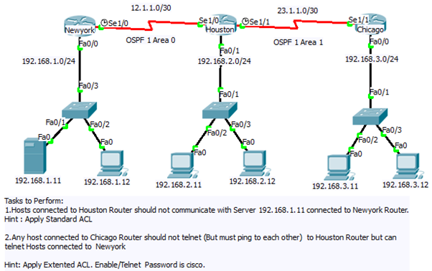

**Deliverables:**

* Complete configuration of the project.
* Detailed report of the project (step by step).

Also, need to write answers of the following questions:

1. What is ACL?
2. Why we use ACL?
3. Where can you Place ACL?
4. What are the main components of ACL?
5. What are the types of ACLs?